Animals on Treadmills: A Walk Through the Scientific Method

Part I – Creative Research
In your group, discuss what makes a good hypothesis. Come up with an inclusive definition and write it down below. Then, discuss the two different types of hypotheses and come up with a definition for each as well.
- Hypothesis: (1 point)
It is an examination theory in assertion of assumption or forecast that will be tried by research. Prior to forming research speculation, read about the subject of interest. In speculation, a researcher is anticipating the connection between factors.

- Two Types: (2 points)

- Straightforward/ Simple Hypothesis

- Complex Hypothesis

Now, discuss with your group about what kind of information can come from studying animals on treadmills. Once you think you have some ideas, develop a basic research and an applied research question and accompanying hypotheses that this kind of data from SHRIMP or PUMAS (highlight your groups assigned topic) on treadmills could test. Indicate whether your questions address proximate or ultimate explanations (by circling one). (6 points)
Basic Research Question: Circle One: Proximate Ultimate
What all does the creature treadmill test for (Proximate)?

Basic Research Hypothesis:
That the shrimp would be dynamic and have the option to move away without getting worn out.

Applied Research Question: Circle One: Proximate Ultimate
How quick can a shrimp really move (Ultimate)?

Applied Research Hypothesis:
Can the treadmill case influence the shrimp in any capacity?

Part II – Evaluating Media Response (Shrimp)
Group Members:
In your group, find an online media response to the video you have been assigned: <https://youtu.be/oX2Ief4kjrI>. The response could be a video or an article. Do not use an article written by the principal author of the research (Dr. David Scholnick). Then answer the following questions.

Which search terms did you use to find your media response to the video? What is the title of the response chosen? Who is the author of the response? (2 points)
“Shrimp on treadmills” is the term I fed in google search to discover my media reaction video.
Mountain-lions-on-treadmills/
Richard Conniff is the author.

Is the media response well stated, clear and unbiased? Why or why not? Does the media response do justice to the complexity of the matter at issue? Why or why not? (2 point)
Yes.
The study was important enough that it was recently published in Science, one of the world’s premier scientific journals.

Does the media response cite relevant evidence, experiences, and/or information essential to the issue? Explain. (2 point)
There wasn’t any relevance cited.
A statement offered what was directly published and didn’t find out on more.

Does the media response develop a definite line of reasoning, explaining well how he or she arrives at his or her conclusions? What information does the media response assume or take for granted? (2 point)
Media responds by developing a definite line of reasoning.
It goes with direction of the politicians without really digging into the matter and not giving into details of the works done and how it was done.

Part II – Evaluating Media Response (Puma)
Group Members:
In your group, find an online media response to the video you have been assigned: <https://youtu.be/G3c1SpV6jvE>. Remember that pumas are also commonly called cougars or mountain lions, so you may want to use these terms in your search. The response could be a video or an article. Do not use an article written by the principal author of the research (Dr. Terrie Williams). Then answer the following questions.
Which search terms did you use to find your media response to the video? What is the title of the response chosen? Who is the author of the response? (2 points)
Mountain lion on a treadmill.
Richard Conniff is the author of House of Lost Worlds.

Is the media response well stated, clear and unbiased? Why or why not? Does the media response do justice to the complexity of the matter at issue? Why or why not? (2 point)
The media responding is not clear and biased.
The unjust portrayed on the matter by the media isn’t acceptable, it can’t give clarity for the whole issues but terms it as a waste of resources and taxpayers money.

Does the media response cite relevant evidence, experiences, and/or information essential to the issue? Explain. (2 point)
There is no relevant cited evidence.
The media publishes what is offered and does not get to involve in the whole issue, this leads to scientist taking all by themselves and responding in newspapers.

Does the media response develop a definite line of reasoning, explaining well how he or she arrives at his or her conclusions? What information does the media response assume or take for granted? (2 point)
There’s a definite line of reasoning by the media.
It supports the politicians to cut off any relevant government support towards research and this shows how ignorant the media is towards discovery.

Part III – Analyzing the Data (Shrimp)
After evaluating various methods to collect respiration data (e.g., runnning shrimp on a treadmill), Dr. Scholnick and his co-authors decided to instead publish a paper based on respiration data collected from resting shrimp in respiration chambers. In their experiment, they injected shrimp (Litopenaeus vannamei) with one of two solutions: a saline solution or a bacteria (Vibrio campbellii) solution. Afterwards, they measured shrimp respiration. Below are the data collected and published.
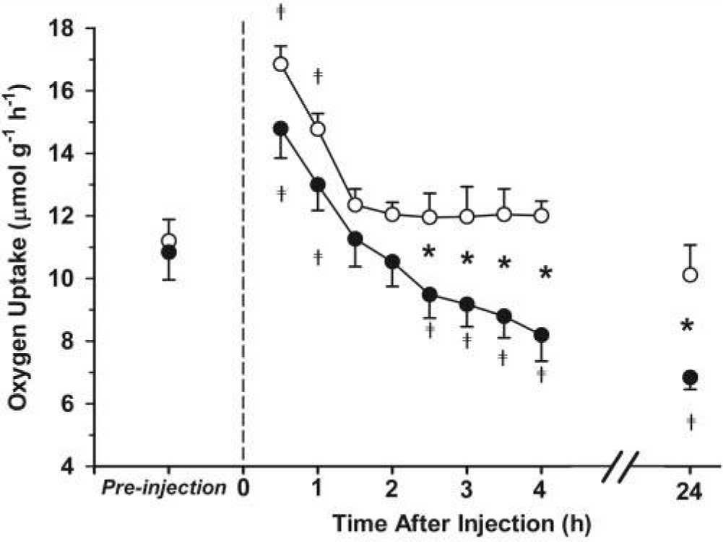
Figure 1. The rate of oxygen uptake (mmol g−1 h−1) of Litopenaeus vannamei following injection with Vibrio campbellii (closed circles) compared to saline injection (open circles). Oxygen uptake was measured in a flow-through respirometry chamber thermostat to 25 °C. Pre-injection values represent average oxygen uptake for 30 min prior to injection. The dashed line represents the injection time. Values post-injection represent averages over 30-min intervals for 6 to 9 shrimp ± standard error. Significant differences between saline (control) and Vibrio injection occurred after 2.5 h (*; P < 0.05 repeated-measures ANOVA). Differences in oxygen uptake from pre-injection values at different times are indicated by crosses. Source: Scholnick, D.A., et al. Impact of exposure to bacteria on metabolism in the penaeid shrimp Litopenaeus vannamei. Biological Bulletin 211: 44–49. © 2006 Marine Biological Laboratory. Used with permission of the publisher, University of Chicago Press.
Answer the following questions about Figure 1. For questions 1 and 2, indicate whether the variable in question is independent or dependent, and whether it is continuous or categorical.
- (1 point) What variable is on the x-axis? Injection
Highlight one for each: Independent or Dependent Continuous or Categorical/Discrete
In 1 hr. after injection dependent discrete
- (1 point) What variable is on the y-axis? Oxygen uptake
Highlight one for each: Independent or Dependent Continuous or Categorical/Discrete
At 10 mole/gram/hour dependent continuous
- (1 point) What do the open and filled dots represent?
Open: saline injection.
Filled: Vibrio campbellii injection
- (2 point) Why is it important that the pre-injection oxygen uptake values are not significantly different than each other?
They are not important due to the fact that they are naturally in their usual state and no optimization.

- (2 point) What happens to oxygen uptake after the shrimp are injected with their assigned solutions?
When saline injection is administered the level of oxygen drops significantly and then remains constant throughout.
When vibrio campbelli is injected the level of oxygen drop is inverse proportional to its respective time.

Part III– Analyzing the Data (Puma)
After placing the pumas on a treadmill, Dr. Williams and her co-authors published a paper based on the data collected. In their own words, the authors: “…monitored behavior-specific energetics of a large cryptic felid, the puma, to evaluate the cost of discrete physiological states involved with ambush hunting. Using a laboratory-to-field approach, we developed and calibrated a new SMART (species movement, acceleration, and radio tracking) wildlife collar on captive, adult pumas (n = 3), with subsequent deployment on wild pumas (n = 4 pumas with SMART collars, 1 puma with GPS only). We created a library of behavior-specific collar acceleration signatures by filming instrumented, trained pumas as they traversed a 20-m level course at different speeds, performed routine activities (resting, eating, grooming, etc.), and ran on a motorized treadmill.”
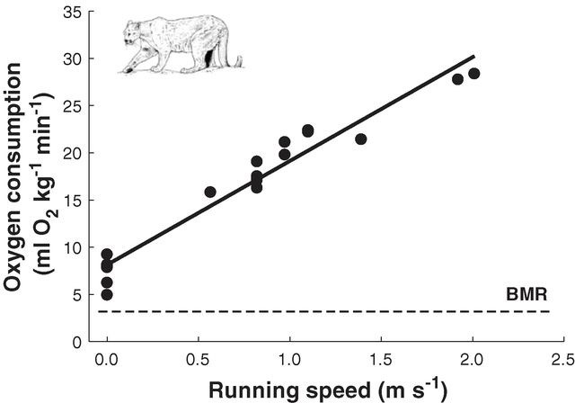
Figure 1: Oxygen consumption in relation to speed for pumas on a treadmill. Points represent individual steady-state measurements. The least-squares regression (solid line) is compared to basal metabolic rate [BMR (basal metabolic rate), dashed line]. Source: Williams, T. M., L. Wolfe, T. Davis, T. Kendall, B. Richter, Y. Wang, C. Bryce, G. H. Elkaim, and C. C. Wilmers. 2014. Instantaneous energetics of puma kills reveal advantage of felid sneak attacks. Science. 346:81-85. Reprinted with permission from AAAS.

Answer the following questions about Figure 1. For questions 1 and 2, indicate whether the variable in question is independent or dependent, and whether it is continuous or categorical.

- (1 point) What variable is on the x-axis? Running speed
Highlight one for each: Independent or Dependent Continuous or Categorical/Discrete
Dependent and Continuous
- (1 point) What variable is on the y-axis? Oxygen consumption.
Highlight one for each: Independent or Dependent Continuous or Categorical/Discrete
Dependent and continuous.
- (2 point) What happens when pumas run at a greater speed?
When running at a greater speed, the rate for oxygen consumption rises thus they are directly proportional.

Part IV – Synthesizing the Information (Shrimp)
Dr. Scholnick responded to media attention to his research by writing an article in the Chronicle of Higher Education. Read the response using the link below and respond to the following questions in no more than three sentences.
<https://web.archive.org/web/20191003060315/https://www.chronicle.com/blogs/conversation/2014/11/13/how-a-47-shrimp-treadmill-became-a-3-million-political-plaything/>

Did the media get the science right? Justify your answer. (2 point)
No
The media has always crying out the money spent at the expense of the research completed and brought to book. This has always impaired them from getting the science right.

Why are the findings of the study important? (2 point)
- To provide a new tool for wildlife conservation.
- To avoid human-animal conflicts by predicting when and where predatory animals hunt.

Would you defend this research against the media response? Why or why not? (1 point)
Yes.
Science has so much to offer, in a comprehensive details, tiny sea organisms have been discovered and have been of great help in discovery of DNA testing which is done daily in our lives.

After reading both the media response and author’s response, do you believe there is a media bias against basic research? Why or why not? (2 point)
The media is a leading front line that will praise the politicians at the expense of overall discovery being held by scientist, this creates bias and barrier to ensure that people get correct information to new inventions.

Part IV – Synthesizing the Information (Puma)
Dr. Williams responded to media attention to her research by writing an article for the LA Times. Read the response using the link below and respond to the following questions in no more than three sentences.
http://www.latimes.com/opinion/op-ed/la-oe-williams-wildlife-coburn-wastebook-20141107-story.html

Did the media get the science right? Justify your answer. (2 point)
No
Intimidating Scientists and criticizing other government-funded studies isn’t a good thing.

Why are the findings of the study important? (2 point)
- To keep away from human-animal clashes by foreseeing when and where savage creatures chase.
- It is important that human learn on essential science of enormous wild creatures and how to live with them.

Would you defend this research against the media response? Why or why not? (1 point)
I defend the research.
Before any argument on why anything was conducted, the media holds the key to make sure the public see both sides of the argument. If anything the media have no ability whatsoever condemn research done by professionals.

After reading both the media response and author’s response, do you believe there is a media bias against basic research? Why or why not? (2 point)
Yes there is bias.
The fact that taxpayer’s money is spent, the media should seek the agenda based on the research, other than that they will play a one sided role which is biased.

